### Planning Proposal – Lot 74, 147 & 148 DP 756894, 542 Spring Flat Road, Spring Flat

|  |
| --- |
| REPORT BY THE Statutory/Strategic Planner to 16 September 2015 council meeting  Planning Proposal - 542 Spring Flat Road  GOV400043, LAN900058 |

RECOMMENDATION

That:

1. the report by the on the be received;

2. the Planning Proposal under Section 55 of the Environmental Planning & Assessment Act 1979 for Spring Flat Road be supported and forwarded to NSW Department of Planning & Environment for Gateway Determination.

#### Executive summary

The purpose of this report is to consider the preparation of an amending Local Environmental Plan (LEP) to allow for the future construction of a dwelling on Lots 74, 147 and 148 DP 756894. The applicant proposes amendments to the minimum lot size for a dwelling to facilitate this. The land is currently zoned RU1 Primary Production with a minimum lot size of 100 hectares (ha).

**Figure 1 – Extract from Comprehensive Land Use Strategy**

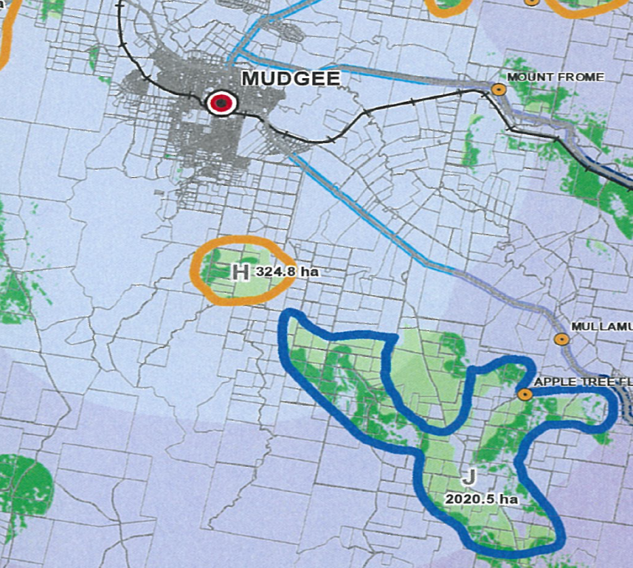

Subject Site

The total area of the land is approximately 25.48ha. The site is located 6.9km from the town centre, approximately 9km by road. Access is obtained from Spring Flat Road which is unsealed but considered suitable for 2wd all-weather access. The dominant land use in the vicinity of the site is extensive agriculture, being the grazing of cattle and sheep.

The land had a dwelling entitlement under a previous LEP (see attachment 2), however this was removed following the gazettal of the Mudgee LEP 1998. Development consent has previously been granted under DA163/97 for the staged construction of a dwelling, however this was never enacted and the consent has since lapsed.

#### Detailed report

**Figure 2 – Subject Site in relation to Mudgee**

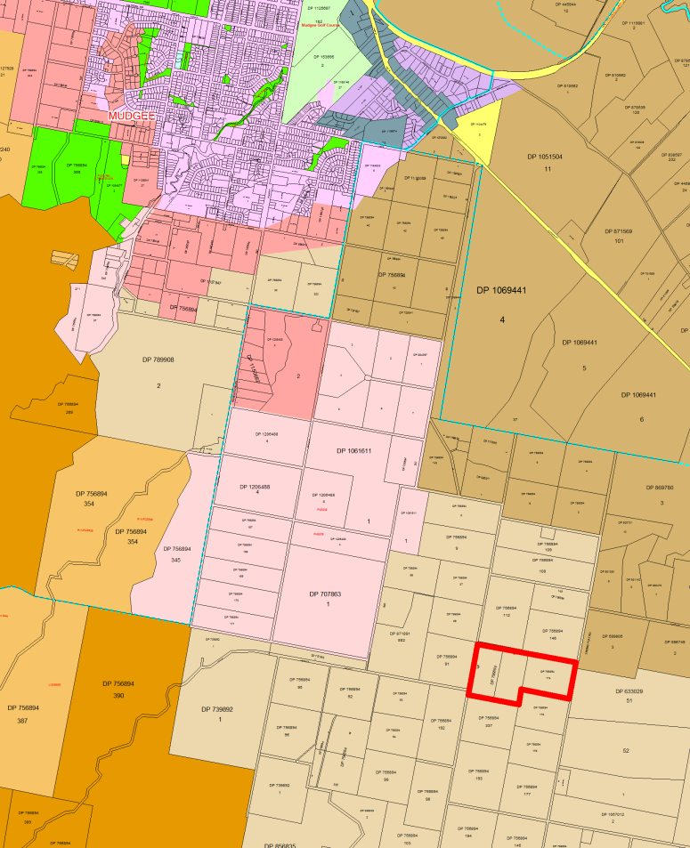

##### 1. OBJECTIVES OR INTENDED OUTCOMES

The intended outcome of the Planning Proposal can be achieved by amending the minimum lot size of the subject land to 20ha, which is the option put forward by the applicant. This, however, will result in a minimum lot size that is inconsistent with the rest of the surrounding RU1 Primary Production zone and will make it more difficult for the objectives of the zone to be achieved.

Another option is to add the construction of a dwelling as an additional permitted use in Schedule 1 of the LEP 2012. This is the preferred option as it will not result in any mapping changes and will not create any additional dwelling entitlements, other than the one that is the subject of this report.

##### 2. EXPLANATION OF PROVISIONS

The proposed outcome will be achieved by preparing an amending Standard Instrument LEP with the following Additional Permitted Use added to Schedule 1:

(a) This clause applies to land at 542 Spring Flat Road, Spring Flat, being Lots 147, 148 and 174 DP 756894.

(b) Development for the purpose of a single dwelling house is permitted with development consent subject to lots 147, 148 and 174 DP 756894 being consolidated into a single lot

##### 3. JUSTIFICATION

**(a) Need for planning proposal**

There is no specific need for the Planning Proposal as the creation of one additional dwelling entitlement is considered to have very minimal impact on the overall supply of housing in the area.

**(b) Relationship to strategic planning framework**

The proposal is inconsistent with the Rural Lifestyle Opportunities map in figure 4-3 in the Comprehensive Land Use Strategy (CLUS) as it is located outside of the identified rural lifestyle opportunity areas. The site is located between Area H, which is identified as a short-term priority, and Area J, a long-term priority. Part 4.7 of the CLUS does, however, state that:

*All “dwelling entitlements” which would have been recognised by a previous planning instrument will be retained. It also proposed to have a provision which makes it clear that lawfully created allotments on which a dwelling house could have been erected will retain that entitlement”.*

This statement was regarding the Comprehensive LEP, which is now known as the LEP 2012. The subject property previously had a dwelling entitlement under clause *Special Provisions – Division 1 – Dwelling Houses* in the Mudgee Local Environmental Plan No. 28 which read:

*(3) Notwithstanding subclause (2), a dwelling house may be erected with consent of the Council –*

*(i) on an allotment created in accordance with clause 11 or 12;*

*(ii) on an existing holding that has an area of not less than 2 hectares and has all-weather vehicular access;*

*(iii) on an allotment that has an area of not less than 40 hectares and was in existence as a separate lot, portion or parcel of land as at 11 February 1985, and was owned separately from any adjoining or adjacent lands as at 11 February 1985; or*

*(iv) on an allotment or portion listed in Schedule 4;*

Schedule 4 of LEP 28 clearly lists Portion 174, Parish of Mudgee (being part of a parcel consisting of portions 147, 148 and 174) as having a dwelling entitlement.

LEP 28 was repealed and replaced with the Mudgee LEP 1998, and the dwelling entitlement not carried over into the new planning instrument. The reason for this is not clear, however it is noted in the explanatory notes for the LEP 1996 (later LEP 1998) that some provisions from previous instruments were not included in the plan either because they were no longer relevant or had been incorporated in the new provisions. The deletion of dwelling entitlements listed in Schedule 4, therefore, appears to have been an oversight.

**(c) Environmental, social and economic impacts**

The endorsement of the Planning Proposal is not anticipated to have any significant social or economic impacts due to its minor nature.

**(d) State and Commonwealth interests**

The applicants report states that there is adequate public infrastructure available to service any future dwelling on the site. Telecommunications and electricity both traverse the site. Water and sewer is not available and would need to be accommodated on site.

##### 4. MAPPING

No mapping changes are required to facilitate this planning proposal if the dwelling entitlement is granted as a scheduled use listed in Schedule 1 of the LEP 2012. Mapping changes will be required if Council chooses to change the zoning or minimum lot size.

##### 5. COMMUNITY CONSULTATION

No community consultation has been undertaken as yet, however, should Council support the Planning Proposal, community consultation requirements will be confirmed by the Department of Planning & Environment as part of the Gateway determination.

#### Financial and Operational Plan implications

Not applicable.

#### Community Plan implications

The strategic planning function comes under the theme ‘Looking After our Community’ in the Community Plan.

|  |  |
| --- | --- |
| MARK LYNDON  STATUTORY/STRATEGIC PLANNER | Liz Densley.jpg  LIZ DENSLEY  ACTING DIRECTOR DEVELOPMENT |

11 August 2015

*Attachments*: (Included at the end of the business paper):

1. Planning Proposal prepared by Minespex

2. Extract from Mudgee Environs LEP 28 with relevant dwelling entitlement provisions highlighted.

APPROVED FOR SUBMISSION:



BRAD CAM

GENERAL MANAGER